Suraj singh
Superset ID: 7808362

WEEK 1 – Assignment Documentation
- Part A: PLSQL Module
- Part B: TDD (Test Driven Development) with JUnit

PART A: PLSQL MODULE
Step 1: Open SQL Developer
- Launch Oracle SQL Developer from your desktop or start menu.
Step 2: Connect to the Database
- Use the connection credentials provided to connect to your Oracle database.
- Example:
  - Username: hr
  - Password: hr
  - Hostname: localhost
  - Port: 1521
  - SID/Service Name: xe
Step 3: Load and Execute SQL Files
- Open each of the .sql files provided in the WEEK 2\plsql folder.
- Files include:
  - create_tables.sql – Creates required tables
  - insert_data.sql – Populates the tables with sample data
  - procedures.sql – Contains stored procedures
  - functions.sql – Contains user-defined functions
  - triggers.sql – Contains trigger definitions
  - test_cases.sql – Test the functionality
Note: To run a file, right-click inside the script editor window and select Run Script (F5).
Step 4: Verify the Outputs
- Use SELECT queries to verify:
  - Data was inserted successfully
  - Procedures and functions return the expected results
  - Triggers are firing correctly
Control Structures Outputs :
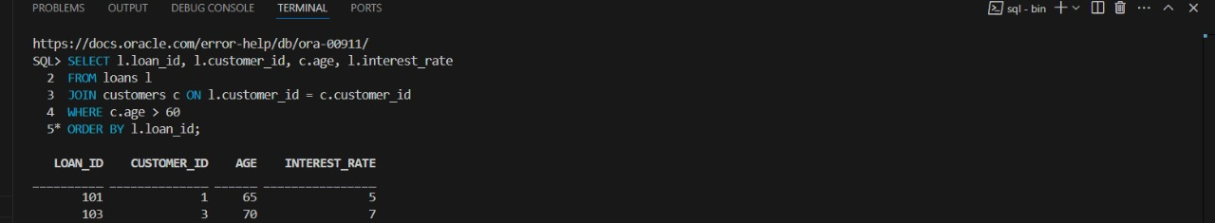
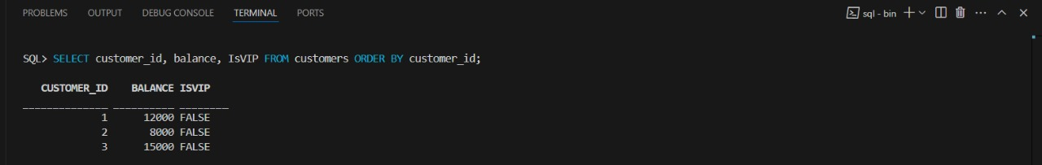
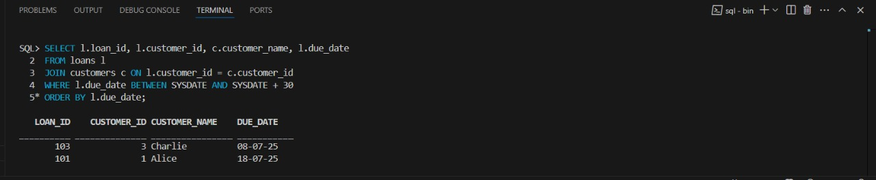
Stored Structures Outputs :
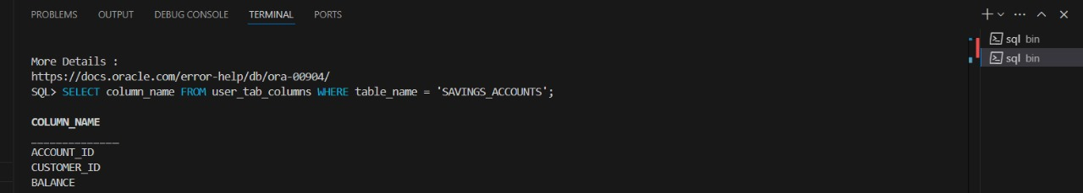
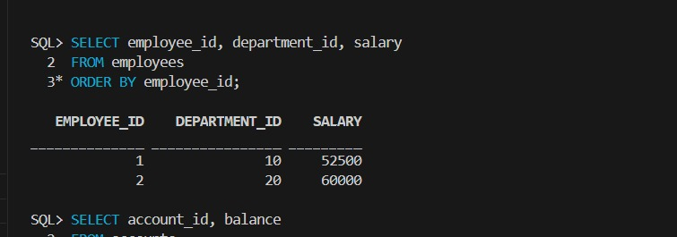
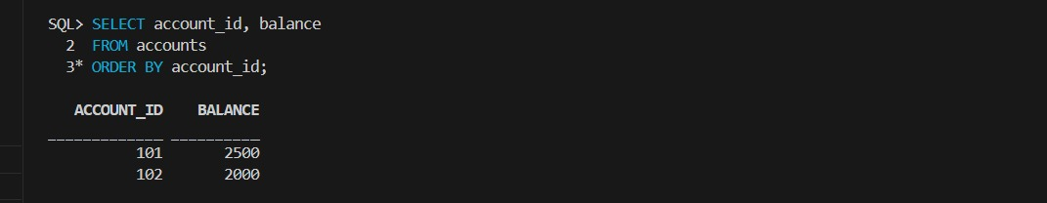

PART B: TDD (Test Driven Development) Module with JUnit
Step 1: Open Eclipse
- Launch Eclipse IDE with JDK and Maven already configured.
Step 2: Import the Project
- Go to File > Import > Maven > Existing Maven Projects
- Browse to the path: WEEK 2\tdd
- Select the project folder and click Finish
Step 3: Explore Project Structure
- Key folders:
  - src/main/java – Contains the source code
  - src/test/java – Contains the JUnit test cases
Step 4: Review the Code
Example: Calculator.java
public class Calculator {
public int add(int a, int b) {
return a + b;
}
}
Example: CalculatorTest.java
import static org.junit.jupiter.api.Assertions.*;
import org.junit.jupiter.api.Test;

public class CalculatorTest {
@Test
public void testAdd() {
Calculator calc = new Calculator();
assertEquals(5, calc.add(2, 3));
}
}
Step 5: Run JUnit Tests
- Right-click the test file or project
- Select Run As > JUnit Test
- Ensure all test cases pass (green bar in JUnit window)

Outputs:
EX 1 Settingup Junitdemo
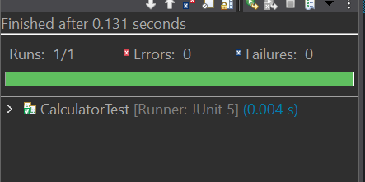
EX 2 AssertionsTest
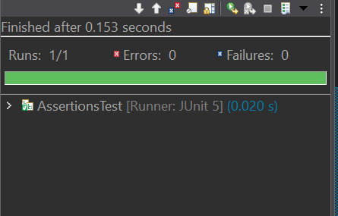
EX 4 AAA
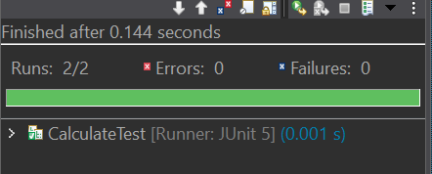
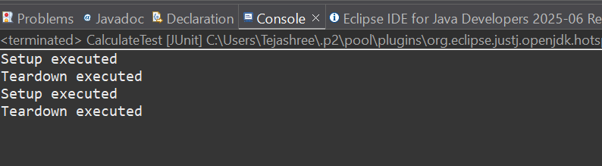
MOCKITO EXERCISES
EX-1 MOCKING & STUBBING
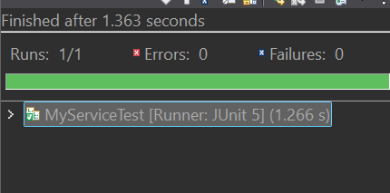
EX-2 VERIFYING & INTERACTIONS
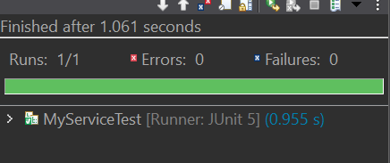
SLF4J LOGGING FRAMEWORK

